**Grand Canyon University**

**CST-117**

MileStone2

**Vien Nguyen**

March 7th, 2020

**Part 1:** Use UML class diagrams to model your inventory item class.

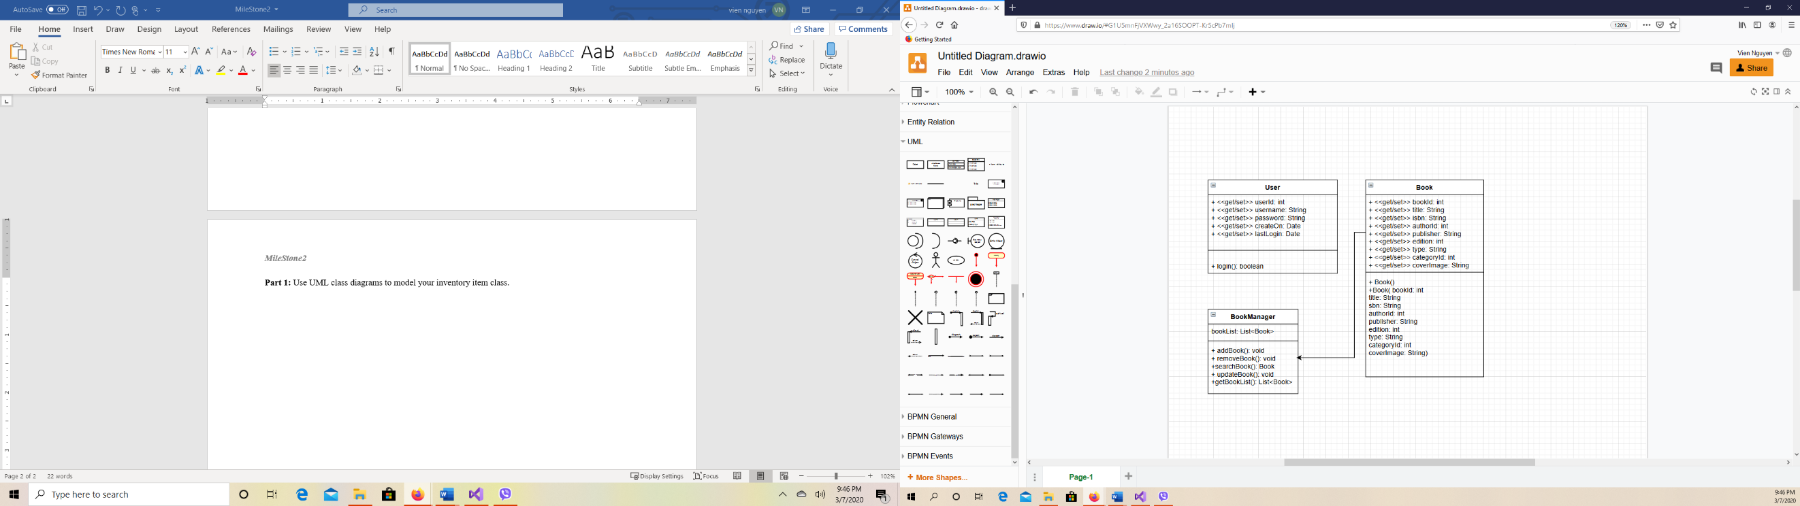

**Part 3:** Test the inventory item class.

**Login form:**  
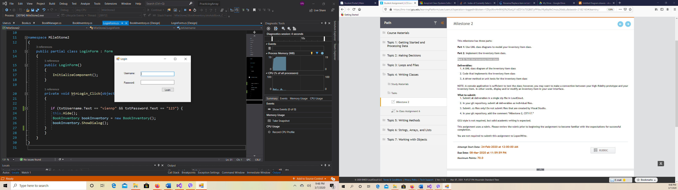

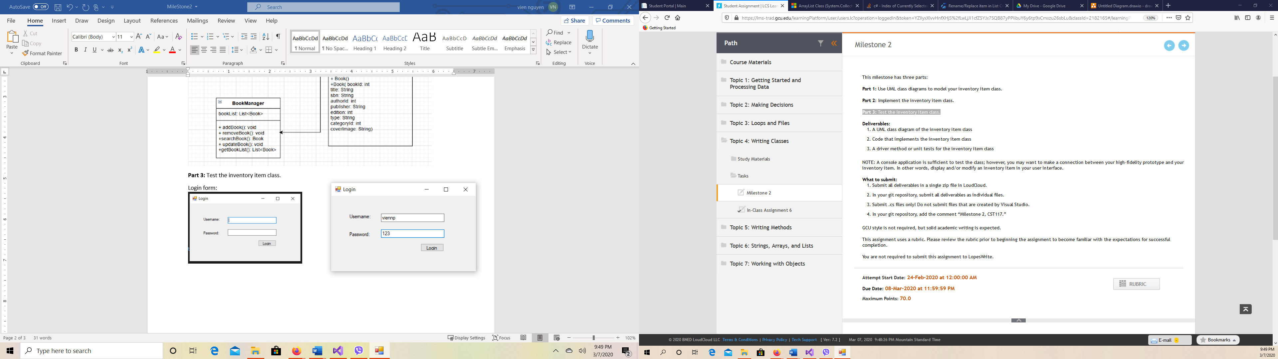

**BookInventory Form:**

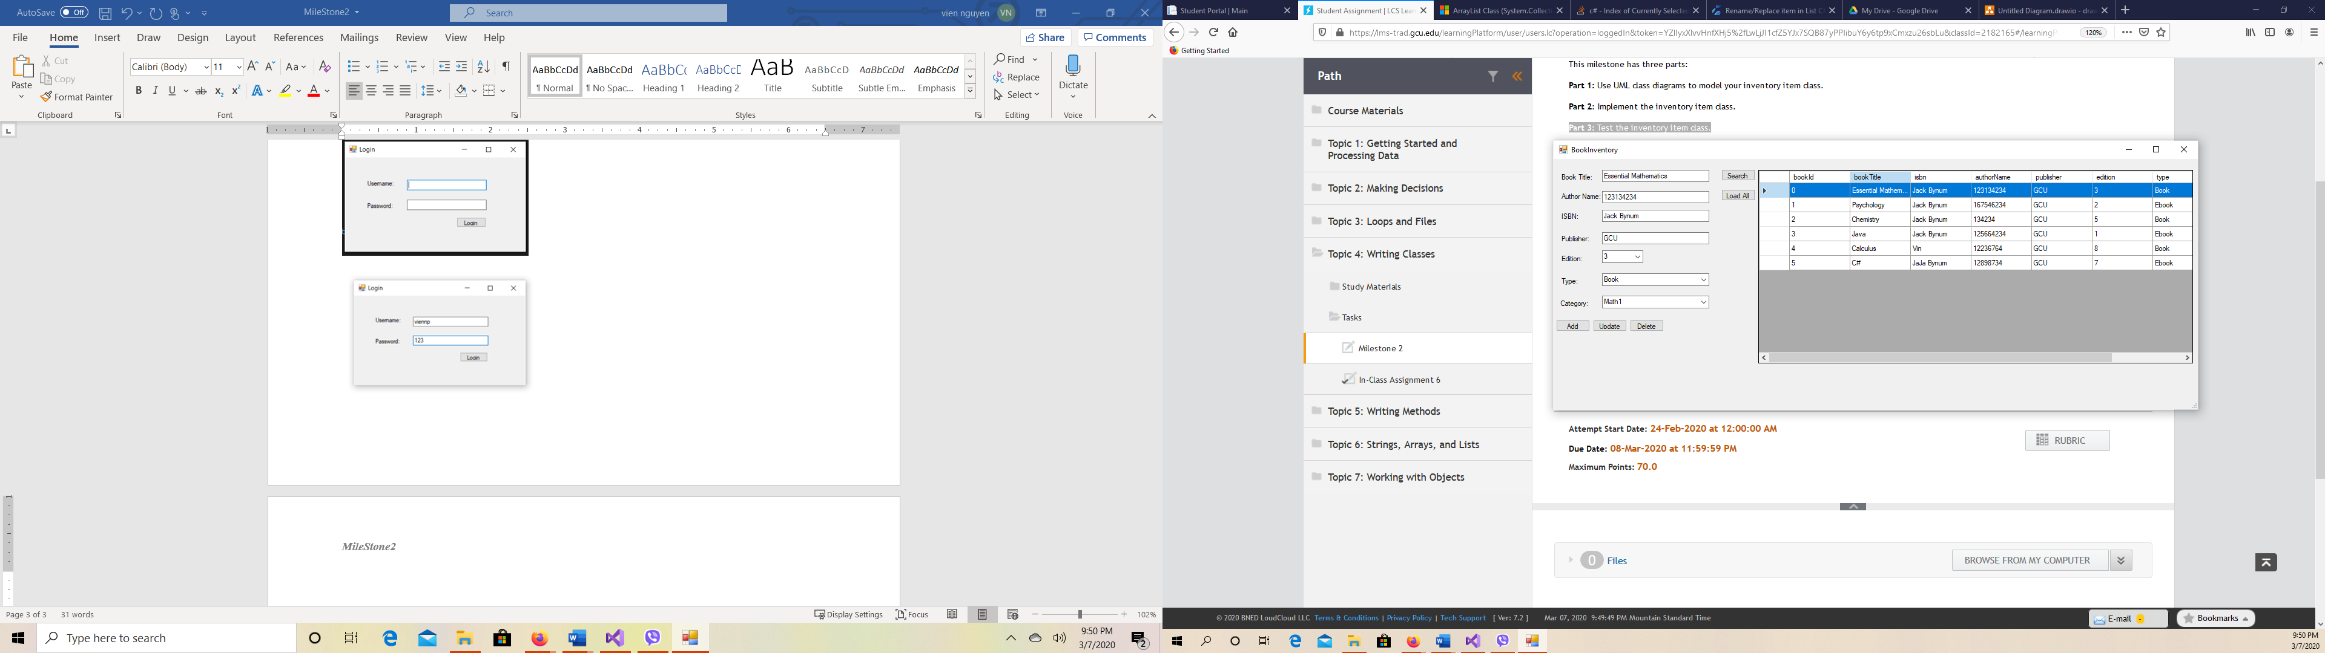

**Add book**

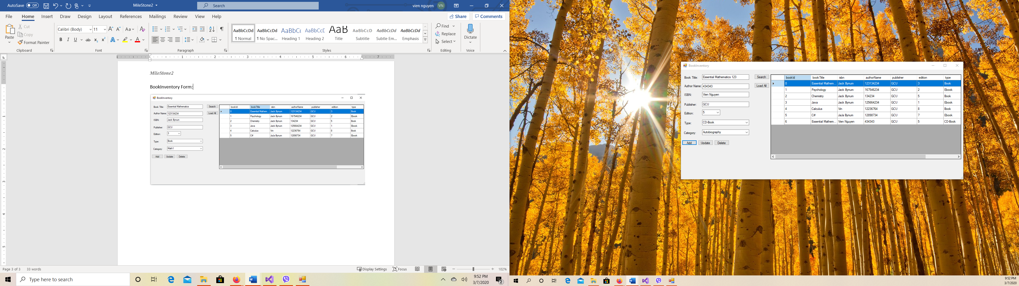

**Update book**

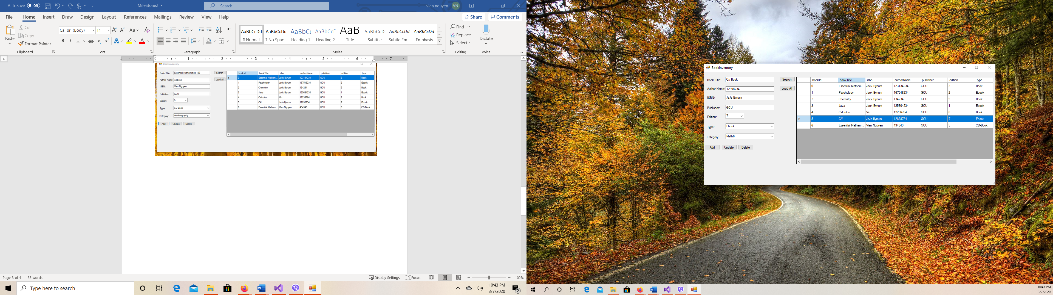

**Delete book**

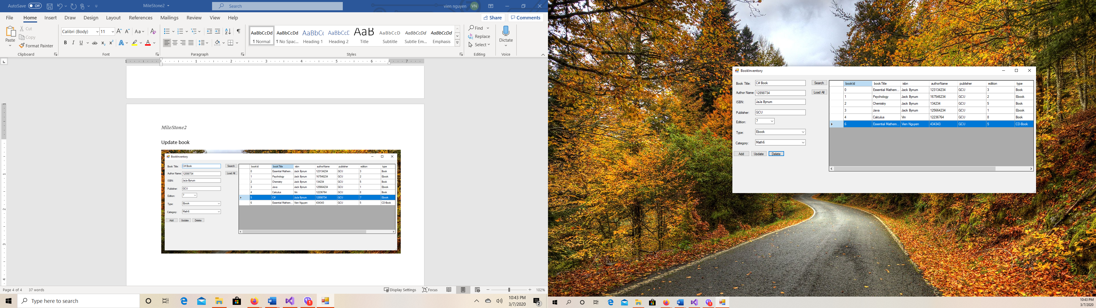

**Search book**

